CIS017-1 – Computer Systems Structure 2021-2022 CIS095-1 – Databases and Computer Networking 2021-2022 Assignment 1 – Design and Implement a Database University ID:2147440 Full Name: Santosh Tamang


CIS017-1 – Computer Systems Structure CIS095-1 – Databases and Computer Networking 2021-2022 Assignment 1 – Design and Implement a Database

INDIVIDUAL REPORT

Student ID: 2147440 Full Name: Santosh Tamang

Page 1 of 36
CIS017-1 – Computer Systems Structure 2021-2022

CIS095-1 – Databases and Computer Networking 2021-2022
Assignment 1 – Design and Implement a Database
University ID:2147440 Full Name: Santosh Tamang

Table of Contents

Introduction/Overview 3

Task Description 3

Tasks: 4

Conceptual / Logical Database Design 4
• Entity Relationship Model 4
• Assumption 5
• Normalisation 5

Physical Database Design (including Data Dictionary) 9

Skeleton Tables 9

Data Dictionary (for each table) 9

Implementation of the Database 16

Query Design and Implementation 22

Discussion / Critical Analysis / Reflection 26

Conclusion 27

References 27

Appendix 28

Page 2 of 36
CIS017-1 – Computer Systems Structure 2021-2022 CIS095-1 – Databases and Computer Networking 2021-2022 Assignment 1 – Design and Implement a Database University ID:2147440 Full Name: Santosh Tamang

Introduction/Overview

The given assignment is about designing and creating a database for a hotel online booking system. The database contains the entities customer, booking, types of room and hotel manager. The attributes of the customer entity are name, address, phone number, email address and credit card information. The attributes of booking are cancelled, check-in date and check-out date. The attributes of types of room are room no., single bedroom and double bedroom. The attributes of the manager entity are employee is no., address, email address and phone no. The data are represented in UNF. The UNF is normalized to 3Nf. The relation between the entities is identified. The ERM is created according to the normalized form and the relation is maintained. My SQL database was selected, and the database was created to fulfil the requirement of the assignment. The required data dictionary was created. The required queries were made to aid in the search of the data when required.

Task Description

A hotel is providing service for customers to book room, check and cancel through online medium. To make a booking, a customer is required to login. If the user is not registered the user should first be registered. A database needs to be created to store the login details (name, address, phone number, email and credit card information) of the customers as well as the booking made by them, with the room type. The verified booking should be allocated only one room as per the required room type. The room should be allocated by the manager. The manager should also login to allocate the room. A database should be created to store the details (name, address, phone number, email address and employee

Page 3 of 36
CIS017-1 – Computer Systems Structure 2021-2022 CIS095-1 – Databases and Computer Networking 2021-2022 Assignment 1 – Design and Implement a Database University ID:2147440 Full Name: Santosh Tamang

number) of login. The hotel manager can see the existing bookings per room to check the availability of the requested room type. The availability of the room is checked by the system created and shown only to the manager.

Tasks:

Conceptual / Logical Database Design

- Entity Relationship Model

According to Guru99 (2022),

“ER Model stands for Entity Relationship Model, also known as ERM is a diagram that displays the relationship of entity sets stored in a database. In other words, ER models help to explain the logical structure of databases. ER models are created based on three basic concepts: entities, attributes and relationships.”
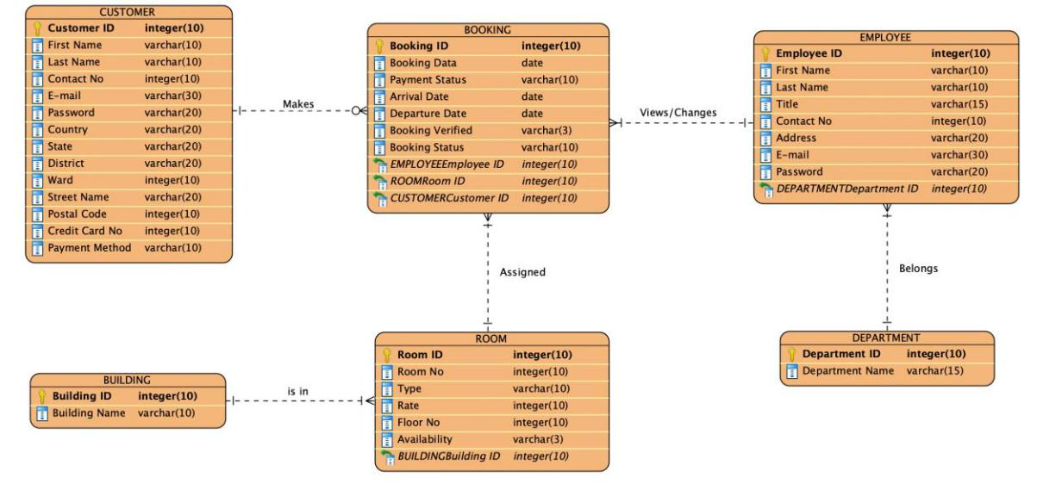

Page 4 of 36
CIS017-1 – Computer Systems Structure 2021-2022 CIS095-1 – Databases and Computer Networking 2021-2022 Assignment 1 – Design and Implement a Database University ID:2147440 Full Name: Santosh Tamang

Fig:1: Entity Relation Module

Here a customer can make multiple bookings, but a booking is assigned only one room as requested by the customer. There are 3 types of rooms that the customer can choose from. A user must log in to book, check and even cancel the booking until the booking becomes active. If a user is not registered, they must register by providing valid credit card no. There are many staffs working in the hotel. They belong to only one department. They all can log in to the hotel's online platform however their actions are limited by their position. Only receptionists and the hotel manager can view the booking made by the user.

- Assumption

The made here are:

- A customer is allowed to book multiple rooms at a time.

- A customer having account may not book a room at all.

- There are a few 5- 10 story buildings.

- There are various departments, where there is at least one employee, and an employee is a member of only one department.

- Staff who are receptionists and manager are allowed to access the information about the booking made by the customer, however, only the manager has the authorization to make the changes in booking i.e., assigning the room as per requested by the users.

- Normalisation

Page 5 of 36
CIS017-1 – Computer Systems Structure 2021-2022 CIS095-1 – Databases and Computer Networking 2021-2022 Assignment 1 – Design and Implement a Database University ID:2147440 Full Name: Santosh Tamang

According to Techopedia (2022),

“Normalization is the process of reorganizing data in a database so that it meets two basic requirements:

- There is no redundancy of data, all data is stored in only one place.

- Data dependencies are logical, all related data items are stored together.

“

Normalisation – Hotel Booking System

UNF |  | 1NF |  |  | 2NF |  |  | 3NF
Customer_ID |  | Customer_ID |  |  | Customer_ID |  |  | Customer_ID
First Name |  | First Name |  |  | First Name |  |  | First Name
Last Name |  | Last Name |  |  | Last Name |  |  | Last Name
Contact No. |  | Contact No. |  |  | Contact No. |  |  | Contact No.
E-Mail |  | E-Mail |  |  | E-Mail |  |  | E-Mail
Password |  | Password |  |  | Password |  |  | Password
Country |  | Country |  |  | Country |  |  | Country
State |  | State |  |  | State |  |  | State
District |  | District |  |  | District |  |  | District
Ward |  | Ward |  |  | Ward |  |  | Ward
Street Name |  | Street Name |  |  | Street Name |  |  | Street Name
Postal Code |  | Postal Code |  |  | Postal Code |  |  | Postal Code
Credit Card No. |  | Credit Card No. |  |  | Credit Card No. |  |  | Credit Card No.
Payment Method |  | Payment Method |  |  | Payment Method |  |  | Payment Method
Booking_ID
Booking Date |  | Customer_ID* |  |  | Customer_ID* |  |  | Customer_ID*

Page 6 of 36
CIS017-1 – Computer Systems Structure 2021-2022 CIS095-1 – Databases and Computer Networking 2021-2022 Assignment 1 – Design and Implement a Database University ID:2147440 Full Name: Santosh Tamang

Payment Status |  | Booking_ID |  |  | Booking_ID |  |  |  | Booking_ID
Arrival Date |  | Booking Date |  |  | Booking Date |  |  |  | Booking Date
Departure Date |  | Payment Status |  |  | Payment Status |  |  |  | Payment Status
Booking Verified |  | Arrival Date |  |  | Arrival Date |  |  |  | Arrival Date
Booking Status |  | Departure Date |  |  | Departure Date |  |  |  | Departure Date
Room_ID |  | Booking Verified |  |  | Booking Verified |  |  |  | Booking Verified
Room No. |  | Booking Status |  |  | Booking Status |  |  |  | Booking Status
Floor No. |  | Room_ID |  |  | Room_ID* |  |  |  | Room_ID*
Type |  | Room No. |  |  | Employee_ID* |  |  |  | Employee_ID*
Rate (per day) |  | Floor No.
Availability |  | Type |  |  | Room_ID |  |  |  | Room_ID
Building_ID |  | Rate (per day) |  |  | Room No. |  |  |  | Room No.
Building Name |  | Availability |  |  | Floor No. |  |  |  | Floor No.
Employee_ID |  | Building_ID |  |  | Type |  |  |  | Type
First Name |  | Building Name |  |  | Rate (per day) |  |  |  | Rate (per day)
Last Name |  | Employee_ID |  |  | Availability |  |  |  | Availability
Title |  | First Name |  |  | Building_ID |  |  |  | Building_ID*
Contact No. |  | Last Name |  |  | Building Name
Address |  | Title |  |  |  |  |  |  | Building_ID
E-Mail |  | Contact No. |  |  | Employee_ID |  |  |  | Building Name
Password |  | Address |  |  | First Name
Department_ID |  | E-Mail |  |  | Last Name |  |  |  | Employee_ID
Name |  | Password |  |  | Title |  |  |  | First Name
 |  | Department_ID |  |  | Contact No. |  |  |  | Last Name
 |  | Name |  |  | Address |  |  |  | Title
 |  | Booking Verified |  |  | E-Mail |  |  |  | Contact No.

Page 7 of 36
CIS017-1 – Computer Systems Structure 2021-2022 CIS095-1 – Databases and Computer Networking 2021-2022 Assignment 1 – Design and Implement a Database University ID:2147440 Full Name: Santosh Tamang

 |  | Password |  | Address
 |  | Department_ID |  | E-Mail
 |  | Name |  | Password
 |  |  |  | Department_ID*
 |  |  |  | Department_ID
 |  |  |  | Name
Table No:1: Normalization Table

The table no.1 shows the normalisation at different phases i.e., 1NF, 2Nf and 3NF. According to the rules of 1NF, the repeating data (group) is separated from the main table. Here, the details of the customers are repeating groups, so it is separated from the main table and a composite key is made at the second table.

As per the 2NF rules, the table having a composite key is checked for the partial-key dependency. The group having full dependency in the key is kept as it is and the group having partial dependency to the key is separated from the table and another table is formed with the composite key (on which the data are related) as primary key. In table no.1, booking id and customer id is created on one table other data are separated.

For the 3NF, the non-key attributes depending on another non-key attribute is checked. In table no.1, department name is only depended on department id, type is only depended on type id and building name is depended on building id only, so they are separated from to form a different table.

Page 8 of 36
CIS017-1 – Computer Systems Structure 2021-2022 CIS095-1 – Databases and Computer Networking 2021-2022 Assignment 1 – Design and Implement a Database University ID:2147440 Full Name: Santosh Tamang

Physical Database Design (including Data Dictionary)

This includes:

Skeleton Tables

CUSTOMER(Customer_ID, First Name, Last Name, Contact No., E-Mail, Password, Country, State, District, Ward, Street Name, Postal Code, Credit Card No., Payment Method)

ROOM(Room_ID, Room No., Floor No., Type, Rate (per day), Availability, Building_ID*)

BUILDING(Building_ID, Building Name)

EMPLOYEE(Employee_ID, First Name, Last Name, Title, Contact No., Address, E-mail, Password, Department_ID*)

DEPARTMENT(Department_ID, Department Name)

BOOKING(Booking_ID, Booking Date, Payment Status, Arrival Date, Departure Date, Booking Verified, Booking Status, Room_ID*, Employee_ID*, Customer ID*)

Data Dictionary (for each table)

Page 9 of 36
CIS017-1 – Computer Systems Structure 2021-2022 CIS095-1 – Databases and Computer Networking 2021-2022 Assignment 1 – Design and Implement a Database University ID:2147440 Full Name: Santosh Tamang

According to Techopedia (2022)’

“A data dictionary is a file or a set of files that contains a database's metadata. The data dictionary contains records about other objects in the database, such as data ownership, data relationships to other objects, and other data.”

CUSTOMER
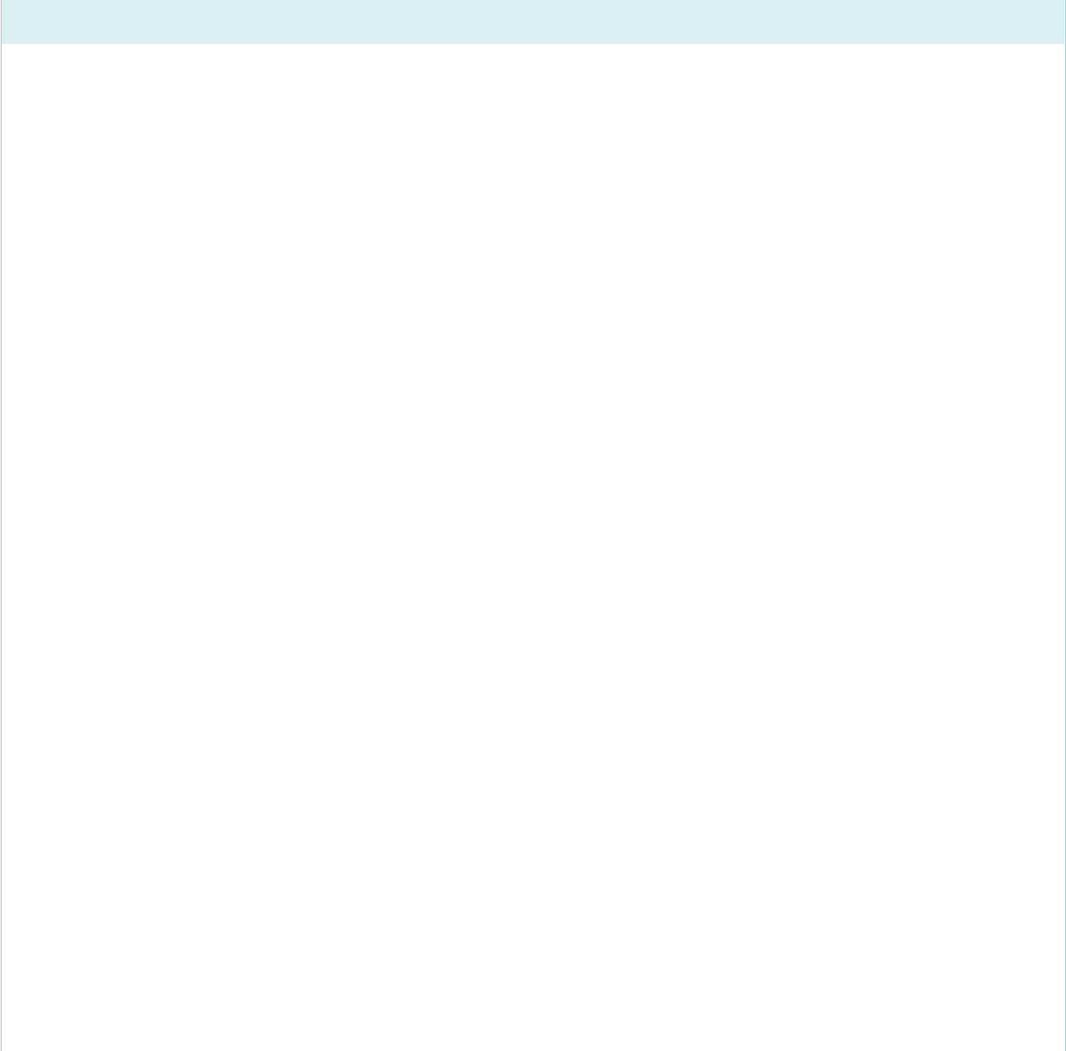

Description: Customer details

 | Field | Datatype | Length | Index | Null | Default | Validation | Description
 | Name |  |  |  |  |  | rule
 | Customer | Int (10) | 10 | PK | No |  |  | Autoincremented
 | ID |  |  |  |  |  |  | Uniquely identifies every
 | (Primary) |  |  |  |  |  |  | customer
 | First | Varchar | 10 |  | No |  |  | First name of customer
 | Name | (10)
 | Last | Varchar | 10 |  | No |  |  | Last name of customer
 | Name | (10)
 | Contact | Int (10) | 10 |  | No |  |  | Customer contact details
 | No
 | Email | Varchar | 30 |  | No |  | Must be | Email of customer
 |  | (30) |  |  |  |  | email
 |  |  |  |  |  |  | format
 |  |  |  |  |  |  | containing
 |  |  |  |  |  |  | an @ and a
 |  |  |  |  |  |  | ‘.’
 |  |  |  |  |  |  | Regex
 |  |  |  |  |  |  | expression
 |  |  |  |  |  |  | used
 | Password | Varchar | 20 |  | No |  | Must | Customer password
 |  | (20) |  |  |  |  | contain at
 |  |  |  |  |  |  | least 8
 |  |  |  | Page 10 of 36

CIS017-1 – Computer Systems Structure 2021-2022 CIS095-1 – Databases and Computer Networking 2021-2022 Assignment 1 – Design and Implement a Database University ID:2147440 Full Name: Santosh Tamang

 |  |  |  |  |  | characters
 |  |  |  |  |  | with
 |  |  |  |  |  | number,
 |  |  |  |  |  | text and
 |  |  |  |  |  | symbols
Country | Varchar | 20 |  | No |  |  | Customer home country
 | (20)
State | Varchar | 20 |  | No |  |  | Name of the state customer is
 | (20) |  |  |  |  |  | living at
District | Varchar | 20 |  | No |  |  | Name of the district customer
 | (20) |  |  |  |  |  | id living at
Ward | Int (10) | 10 |  | No |  |  | Ward no. of the area customer
 |  |  |  |  |  |  | is living at
Street | Varchar | 20 |  | No |  |  | Exact location of the customer
Name | (20)
Postal | Int (10) | 10 |  | No |  |  | Postal code of the area of the
Code |  |  |  |  |  |  | customer
Credit | Varchar | 15 |  | No |  |  | Customer credit card detail
Card No | (15)
Payment | Varchar | 10 |  | No |  |  | Medium to pay the bill at the
Method | (10) |  |  |  |  |  | end

Index

Key name | Type | Unique | Column | Null
PRIMARY | BTREE | Yes | Customer ID | No

DEPARTMENT
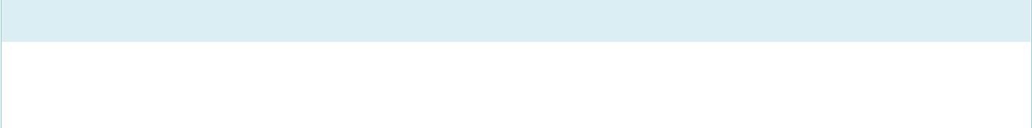

Description: Department details

Field | Datatype | Length | Index | Null | Default | Validation | Description
Name |  |  |  |  |  | rule
 |  |  | Page 11 of 36

CIS017-1 – Computer Systems Structure 2021-2022 CIS095-1 – Databases and Computer Networking 2021-2022 Assignment 1 – Design and Implement a Database University ID:2147440 Full Name: Santosh Tamang

Department | Int (10) | 10 | PK | No |  |  | Autoincremented
ID |  |  |  |  |  |  | Uniquely identifies every
(Primary) |  |  |  |  |  |  | department
Department | Varchar | 15 |  | No |  |  | Name of the departments
Name | (15)

Index

Key name | Type | Unique | Column | Null
PRIMARY | BTREE | Yes | Department ID | No
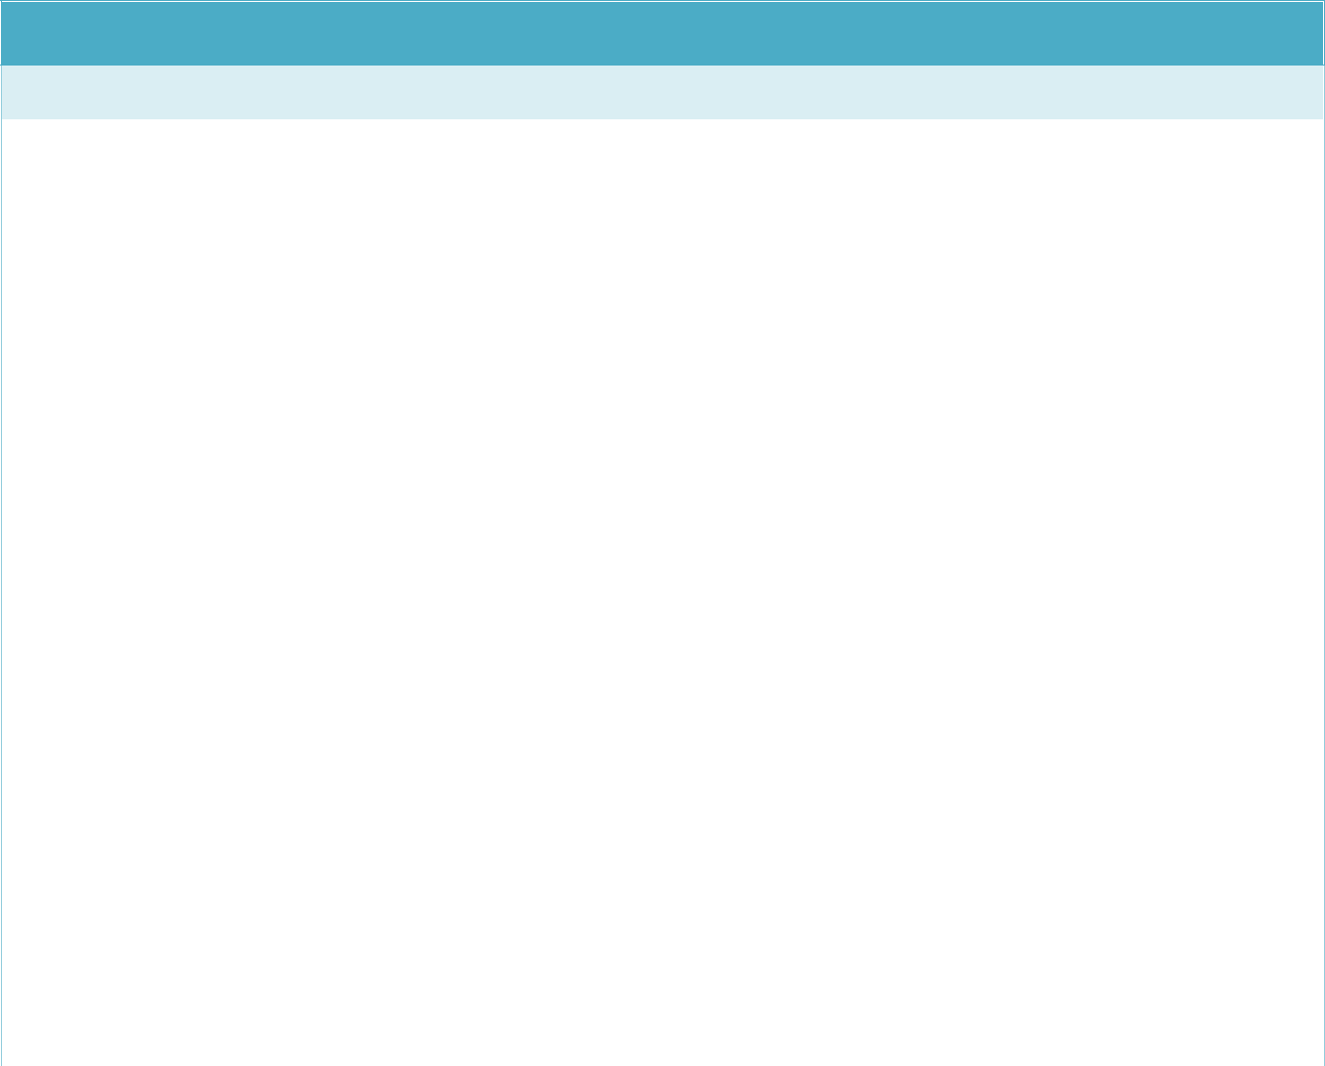

EMPLOYEE

Description: Employee details

 | Field | Datatype | Length | Index | Null | Default | Validation | Description
 | Name |  |  |  |  |  | rule
 | Employee | Int (10) | 10 | PK | No |  |  | Autoincremented
 | ID |  |  |  |  |  |  | Uniquely identifies every
 | (Primary) |  |  |  |  |  |  | employee
 | First Name | Varchar | 10 |  | No |  |  | First name of employee
 |  | (10)
 | Last Name | Varchar | 10 |  | No |  |  | Last name of employee
 |  | (10)
 | Title | Varchar | 15 |  | No |  |  | Designation of the employee
 |  | (15)
 | Contact No | Int (10) | 10 |  | No |  |  | Employee contact details
 | Address | Varchar | 20 |  | No |  |  | Address of the employee
 |  | (20)
 | Email | Varchar | 30 |  | No |  | Must be | Email of employee
 |  | (30) |  |  |  |  | email
 |  |  |  |  |  |  | format
 |  |  |  | Page 12 of 36

CIS017-1 – Computer Systems Structure 2021-2022 CIS095-1 – Databases and Computer Networking 2021-2022 Assignment 1 – Design and Implement a Database University ID:2147440 Full Name: Santosh Tamang

 |  |  |  |  |  | containing
 |  |  |  |  |  | an @ and a
 |  |  |  |  |  | ‘.’
 |  |  |  |  |  | Regex
 |  |  |  |  |  | expression
 |  |  |  |  |  | used
Password | Varchar | 20 |  | No |  | Must | Employee password
 | (20) |  |  |  |  | contain at
 |  |  |  |  |  | least 8
 |  |  |  |  |  | characters
 |  |  |  |  |  | with
 |  |  |  |  |  | number,
 |  |  |  |  |  | text and
 |  |  |  |  |  | symbols
Department | Int (10) | 10 | MUL | No |  |  | Uniquely identifies the
ID |  |  |  |  |  |  | department

Index

Key name | Type | Unique | Column | Null
PRIMARY | BTREE | Yes | Employee ID | No
FOREIGN | BTREE | No | Department ID | No
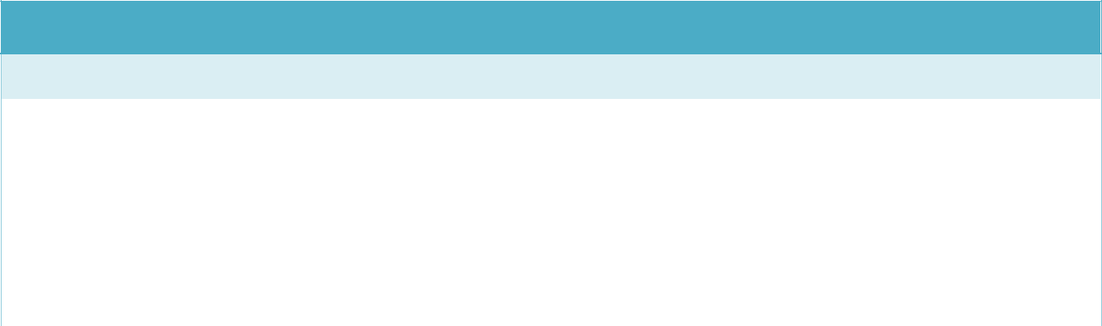

BUILDING

Description: Building details

 | Field | Datatype | Length | Index | Null | Default | Validation | Description
 | Name |  |  |  |  |  | rule
 | Building | Int (10) | 10 | PK | No |  |  | Autoincremented
 | ID |  |  |  |  |  |  | Uniquely identifies every
 | (Primary) |  |  |  |  |  |  | building

Page 13 of 36
CIS017-1 – Computer Systems Structure 2021-2022 CIS095-1 – Databases and Computer Networking 2021-2022 Assignment 1 – Design and Implement a Database University ID:2147440 Full Name: Santosh Tamang

Building Name

Varchar (15)

15

No

Name of the building

Index

Key name | Type | Unique | Column | Null
PRIMARY | BTREE | Yes | Building ID | No

 | ROOM
 | Description: Room details
Field |  | Datatype |  | Length | Index |  | Null | Default |  | Validation |  | Description
Name |  |  |  |  |  |  |  |  |  | rule
 | Room ID | Int (10) |  | 10 | PK |  | No |  |  |  |  | Autoincremented
 | (Primary) |  |  |  |  |  |  |  |  |  |  | Uniquely | identifies |  | every
 |  |  |  |  |  |  |  |  |  |  |  | room
Room No |  | Int (10) |  | 10 |  |  | No |  |  |  |  | The room no
 | Type | Varchar |  | 10 |  |  | No |  |  |  |  | The room type
 |  | (10)
Rate |  | Int (10) |  | 10 |  |  | No |  |  |  |  | The cost of the room per
 |  |  |  |  |  |  |  |  |  |  |  | night
 | Floor No | Int (10) |  | 10 |  |  | No |  |  |  |  | The floor no of the room
Availability |  | Varchar |  | 3 |  |  | No |  |  | Yes or No |  | The status of the room
 |  | (3) |  |  |  |  |  |  |  | only |  | (empty or occupied)
 | Building ID | Int (10) |  | 10 | MUL |  | No |  |  |  |  | Uniquely | identifies |  | the
 |  |  |  |  |  |  |  |  |  |  |  | building
Index
Key name |  |  | Type |  |  | Unique |  |  | Column |  |  | Null
PRIMARY |  |  | BTREE |  |  | Yes |  |  | Room ID |  |  | No
FOREIGN |  |  | BTREE |  |  | No |  |  | Building ID |  |  | No

Page 14 of 36

CIS017-1 – Computer Systems Structure 2021-2022 CIS095-1 – Databases and Computer Networking 2021-2022 Assignment 1 – Design and Implement a Database University ID:2147440 Full Name: Santosh Tamang

BOOKING


Description: Booking details

 | Field | Datatype | Length | Index | Null | Default | Validation |  | Description
 | Name |  |  |  |  |  | rule
 | Booking | Int (10) | 10 | PK | No |  |  |  | Autoincremented
 | ID |  |  |  |  |  |  |  | Uniquely | identifies | every
 | (Primary) |  |  |  |  |  |  |  | booking
 | Booking | Date |  |  | No |  | Must be in |  | The date of booking the room
 | Date |  |  |  |  |  | the | format | by the customer
 |  |  |  |  |  |  | of | yyyy-
 |  |  |  |  |  |  | mm-dd
 | Payment | Varchar | 10 |  | No | Not |  |  | The advance payment status
 | Status | (10) |  |  |  | Paid |  |  | of the customer
 | Arrival | Date |  |  | No |  | Must be in |  | The guest check in date
 | Date |  |  |  |  |  | the | format
 |  |  |  |  |  |  | of | yyyy-
 |  |  |  |  |  |  | mm-dd
 | Departure | Date |  |  | No |  | Must be in |  | The checkout date of the guest
 | Date |  |  |  |  |  | the | format
 |  |  |  |  |  |  | of | yyyy-
 |  |  |  |  |  |  | mm-dd
 | Booking | Varchar | 3 |  | No | No | Yes or No |  | The status of the booking
 | Verified | (3) |  |  |  |  | only |  | verification
 | Booking | Varchar | 10 |  | No | Pending |  |  | The status of the room
 | Status | (10) |  |  |  |  |  |  | assigned
 | Employee | Int (10) | 10 | MUL | No |  |  |  | Uniquely | identifies | the
 | ID |  |  |  |  |  |  |  | employee
 | Room ID | Int (10) | 10 | MUL | No | 0 |  |  | Uniquely identifies the rooms

Page 15 of 36
CIS017-1 – Computer Systems Structure 2021-2022 CIS095-1 – Databases and Computer Networking 2021-2022 Assignment 1 – Design and Implement a Database University ID:2147440 Full Name: Santosh Tamang

Customer ID

Int (10)

10

MUL

No

Uniquely identifies the

customers

Index

Key name | Type | Unique | Column | Null
PRIMARY | BTREE | Yes | Booking ID | No
FOREIGN | BTREE | No | Employee ID | No
FOREIGN | BTREE | No | Room ID | No
FOREIGN | BTREE | No | Customer ID | No

Implementation of the Database

The RDMS used to create the database for this assignment is MySql database.
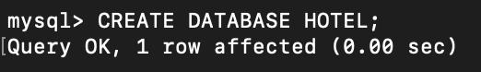

Fig:2: Database creation

The query creates database where we can create various table inside this database.
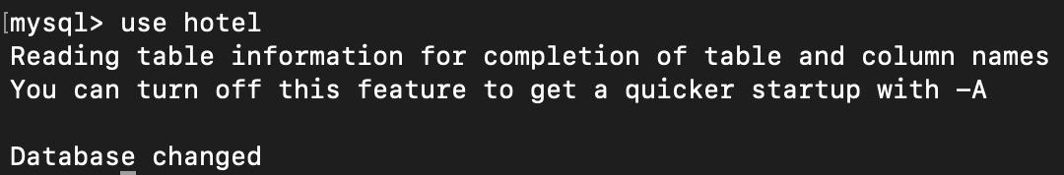

Fig:3: Using created database

The query uses the database already created previously.

Page 16 of 36

CIS017-1 – Computer Systems Structure 2021-2022 CIS095-1 – Databases and Computer Networking 2021-2022 Assignment 1 – Design and Implement a Database University ID:2147440 Full Name: Santosh Tamang
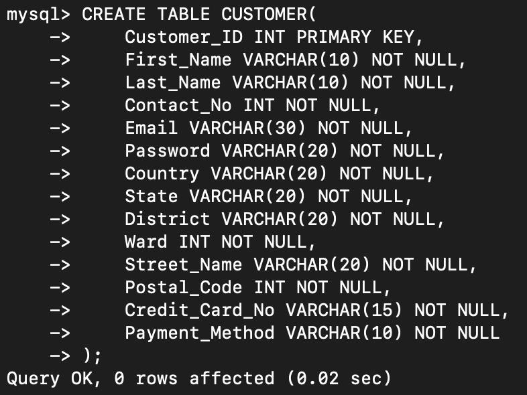

Fig:4: Creating customer table

The query creates a table customer with the primary key customer id and the various attributes with the required constraints.
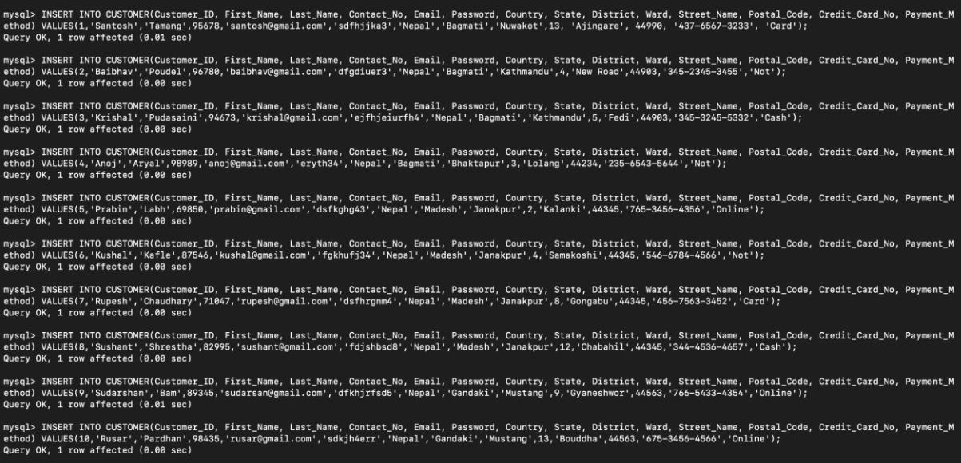

Fig:5: Inserting data into the table customer

Page 17 of 36
CIS017-1 – Computer Systems Structure 2021-2022 CIS095-1 – Databases and Computer Networking 2021-2022 Assignment 1 – Design and Implement a Database University ID:2147440 Full Name: Santosh Tamang

The query inserts data into the already created table customer.
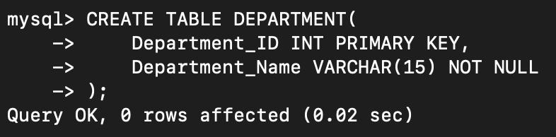

Fig:6: Creating department table

The creates a table department with a primary key department id and department name as an attribute.
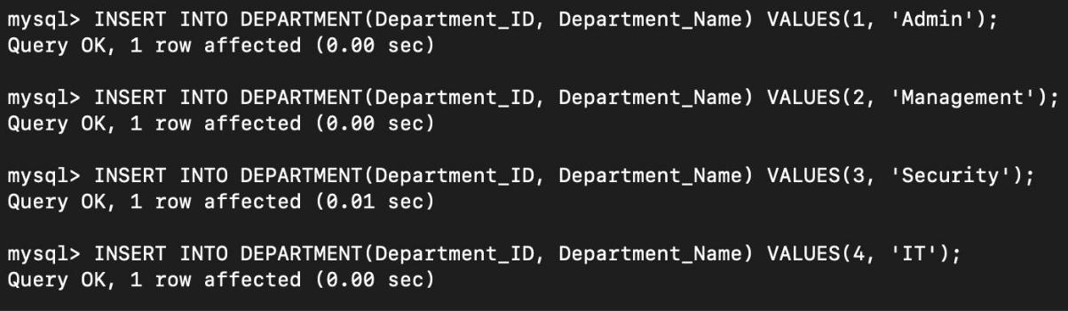

Fig:7: Inserting data into department table

The query inserts data into department table.

Page 18 of 36
CIS017-1 – Computer Systems Structure 2021-2022 CIS095-1 – Databases and Computer Networking 2021-2022 Assignment 1 – Design and Implement a Database University ID:2147440 Full Name: Santosh Tamang
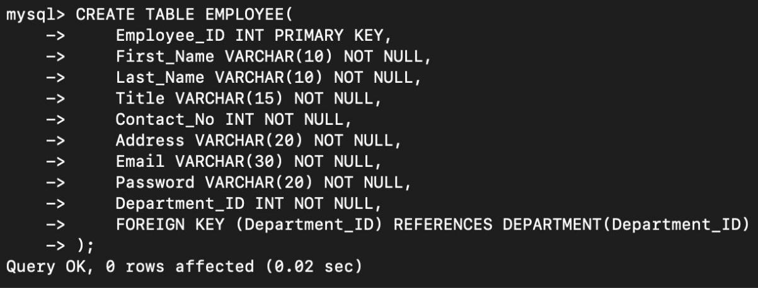

Fig:8: Creating table employee

The query creates a table employee with a primary key employee id and other attributes along with department id as foreign.
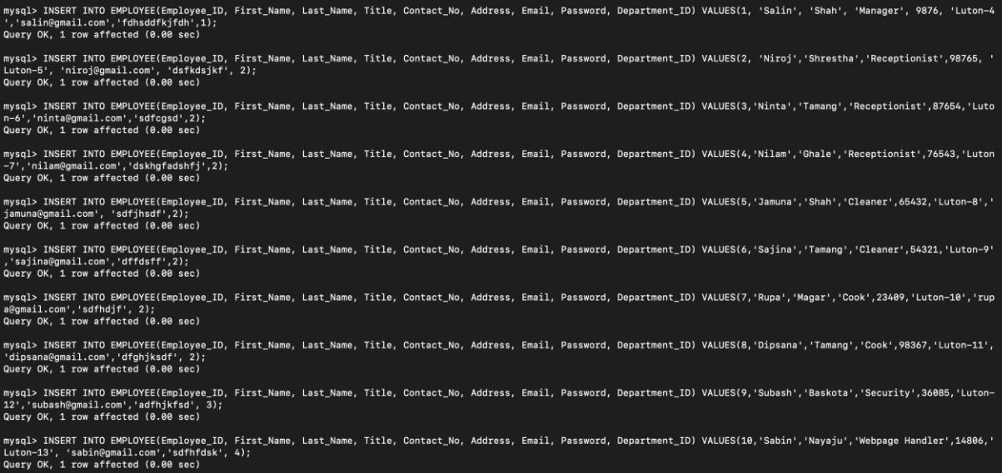

Fig:9: Inserting data into employee table

The query inserts data into employee table.

Page 19 of 36
CIS017-1 – Computer Systems Structure 2021-2022 CIS095-1 – Databases and Computer Networking 2021-2022 Assignment 1 – Design and Implement a Database University ID:2147440 Full Name: Santosh Tamang
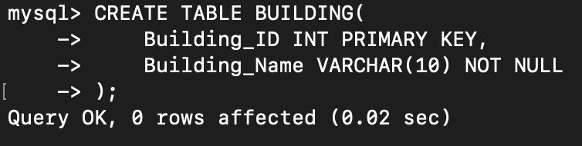

Fig:10: Creating table building

The query creates table building with primary key building id.
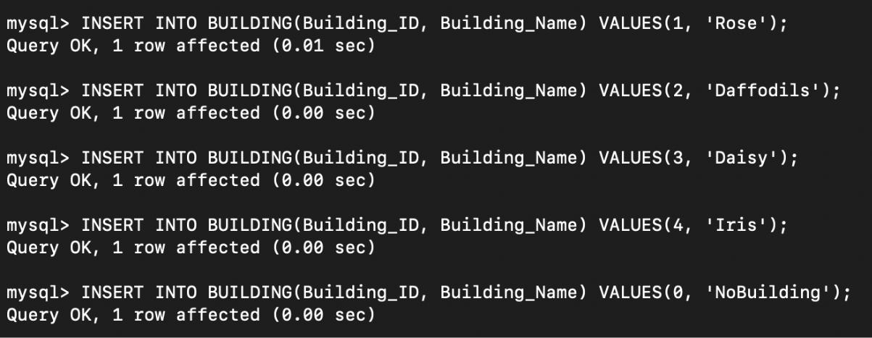

Fig:11: Inserting data into building table

The query inserts data into building table.
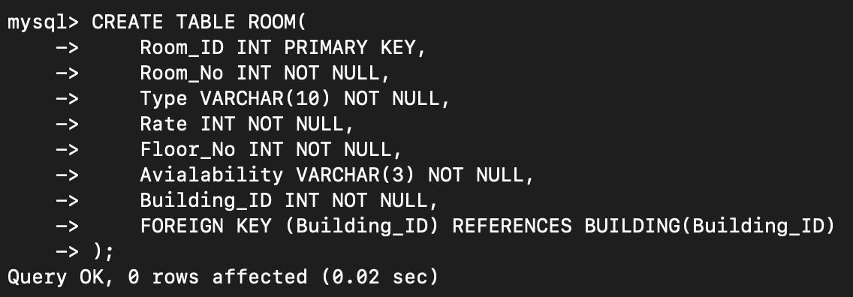

Fif:12: Creating table room

Page 20 of 36
CIS017-1 – Computer Systems Structure 2021-2022 CIS095-1 – Databases and Computer Networking 2021-2022 Assignment 1 – Design and Implement a Database University ID:2147440 Full Name: Santosh Tamang

The query creates room table with primary key room id and building id as foreign key.
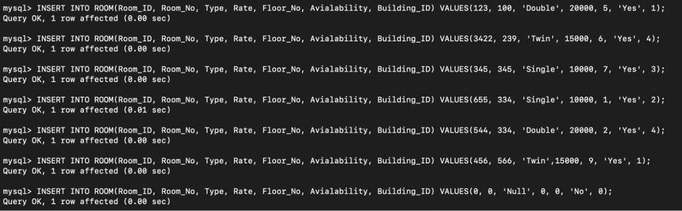

Fig:13: Inserting data into table room

The query inserts data into room table.
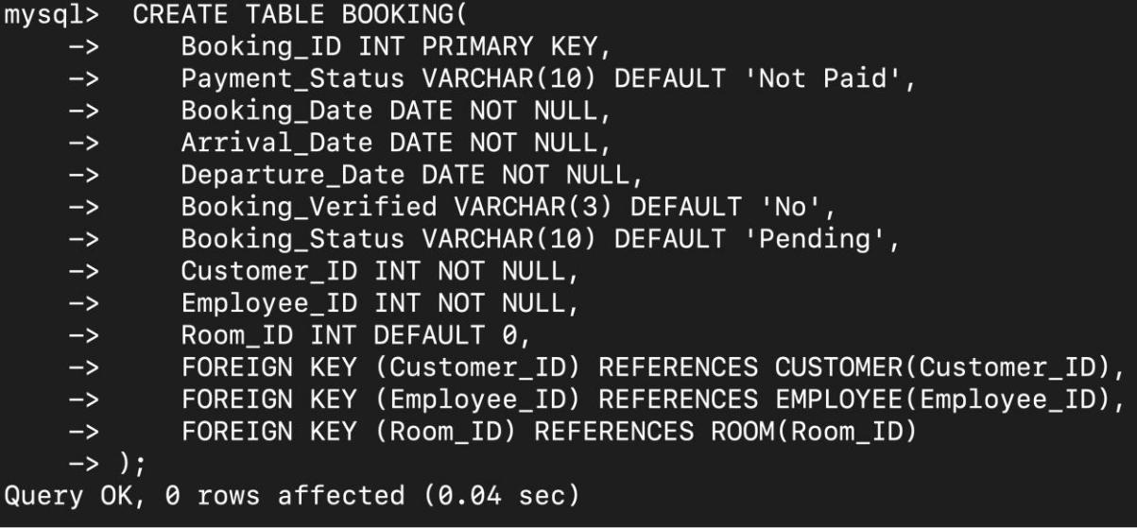

Fig:14: Creating table booking

The query creates booking table with primary key booking id and customer id, employee id and room id as foreign key.

Page 21 of 36
CIS017-1 – Computer Systems Structure 2021-2022 CIS095-1 – Databases and Computer Networking 2021-2022 Assignment 1 – Design and Implement a Database University ID:2147440 Full Name: Santosh Tamang
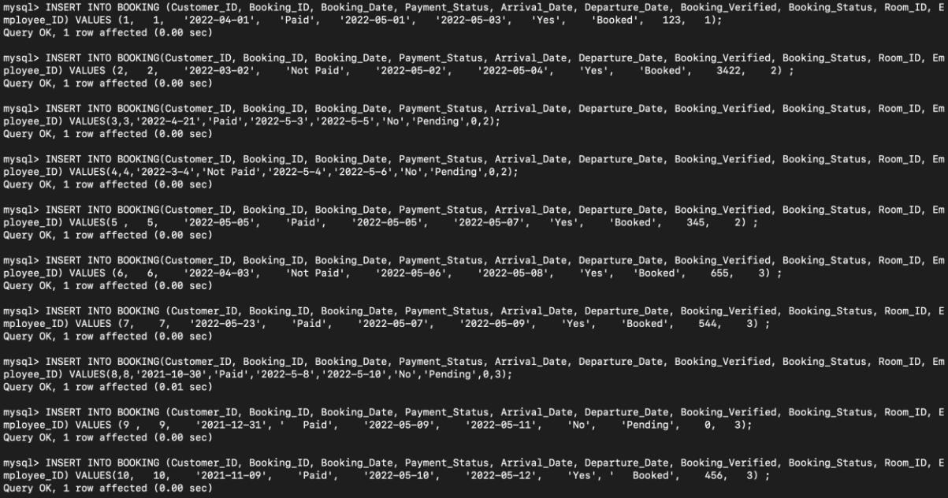

Fig:15: Inserting data into table booking

The query inserts data into the booking table.

Query Design and Implementation

Queries

- Show all the user’s detail with the no. of booking they made.

Page 22 of 36
CIS017-1 – Computer Systems Structure 2021-2022 CIS095-1 – Databases and Computer Networking 2021-2022 Assignment 1 – Design and Implement a Database University ID:2147440 Full Name: Santosh Tamang
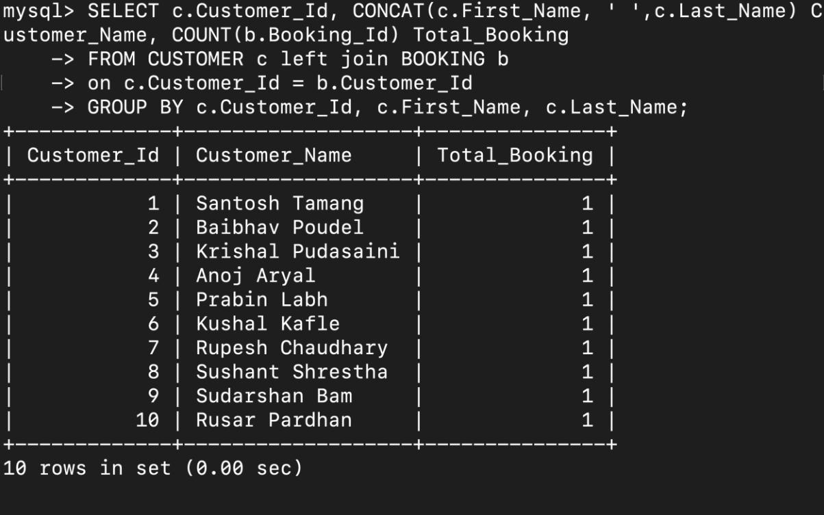

Fig:16: Query to show user’s detail with no. of booking made

The query utilizes the concat function and the left outer join to view all user’s detail who have logged in. To provide some discount to the customer who comes more frequently than others.

- Show the month which has max no. of guests checked in.
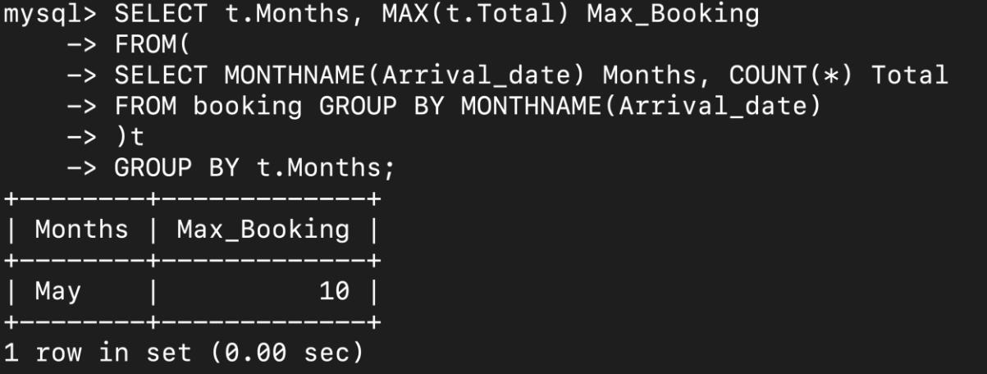

Page 23 of 36
CIS017-1 – Computer Systems Structure 2021-2022 CIS095-1 – Databases and Computer Networking 2021-2022 Assignment 1 – Design and Implement a Database University ID:2147440 Full Name: Santosh Tamang

Fig:17: Query to show the month and no. of booking made with highest no. of guest came

The query utilizes sub-query to show the month in which maximum no. of guest came.

This helps to prepare for the future stocking.

- Update when the booking is cancelled.

Fig:18: Query to update when cancellation is done

The query updates the booking table and make the booking status “cancelled”. To make the room available for the future use.

- Show the rooms that are currently occupied.
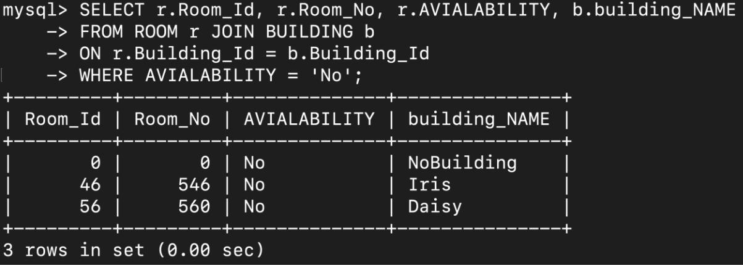

Fig:19: Query to show the occupied room

The query utilizes inner join to show the required data only. To make a queue of booking.

Page 24 of 36
CIS017-1 – Computer Systems Structure 2021-2022 CIS095-1 – Databases and Computer Networking 2021-2022 Assignment 1 – Design and Implement a Database University ID:2147440 Full Name: Santosh Tamang

- Show the total bill.
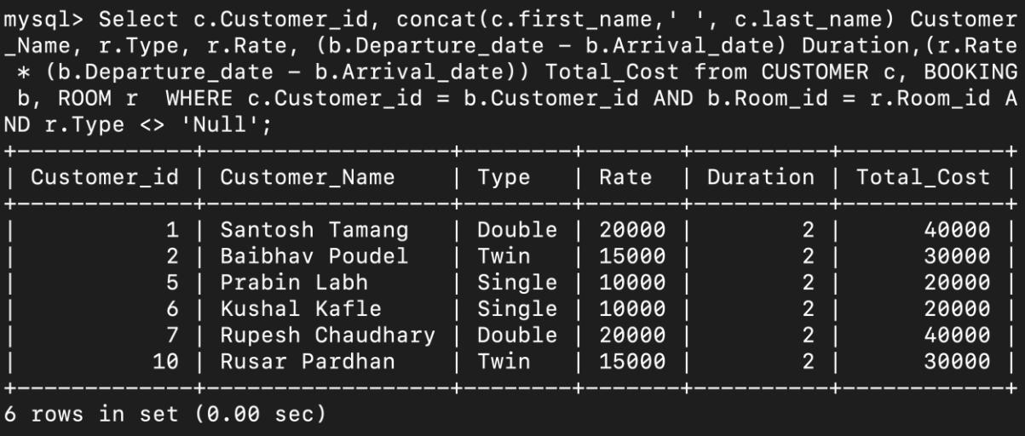

Fig:20: Query to calculate the bill

The query utilizes concat function to show the customer’s name and calculates the bill. For the user to pay their due.

- Show the customer details where the booking is pending.
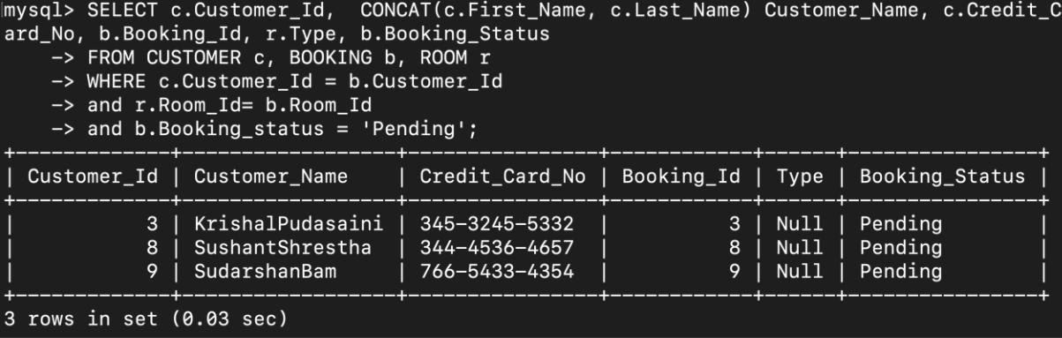

Fig:21: Query to show the pending booking

The query shows the customer detail whose booking status is pending. The staff should assign the room.

Page 25 of 36
CIS017-1 – Computer Systems Structure 2021-2022 CIS095-1 – Databases and Computer Networking 2021-2022 Assignment 1 – Design and Implement a Database University ID:2147440 Full Name: Santosh Tamang

- Show the detail of the staff with the no. of rooms they assigned till now.
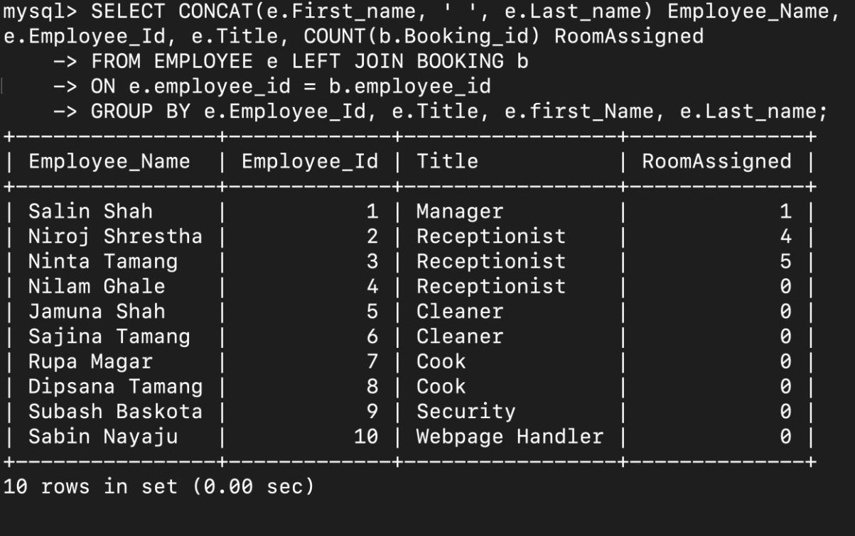

Fig:22: Query to show the employee detail

The query shows the employee detail utilizing left join and the no. of room assigned to the customer. To know who has checked the user request.

Discussion / Critical Analysis / Reflection

The requirement for the assignment is fulfilled. The customer can log in and register in the hotel. They can book rooms of their preferences. The hotel staff can view the user’s booking details and assign a room according to the user's preferences.

Page 26 of 36
CIS017-1 – Computer Systems Structure 2021-2022 CIS095-1 – Databases and Computer Networking 2021-2022 Assignment 1 – Design and Implement a Database University ID:2147440 Full Name: Santosh Tamang

Yes, the time allotted for the assignment was sufficient for the assignment to be completed prior to the submission due date. No, the assignment was not harder than my expectation. Even so, there were many small errors which affected the performance. The error made this time will not be made next time.

The enhancement of the knowledge of the database was done.

Conclusion

The given assignment asked to create a database system for the hotel that wants to provide the services like booking, cancelling, and checking the booking status through an online medium. For the completion of the assignment, MySQL database was used. Yes, the requirements were fulfilled as per the need of the client.

References

Guru99 2022.Entity Relationship (ER) Diagram Model with DBMS Example. Accessed on: 17th August, 2022. Retrieved from: https://www.guru99.com/er-diagram-tutorial-dbms.html

Techopedia 2022. What Does Normalization Mean?. Accessed on: 17th August,

2022. Retrieved from:

https://www.techopedia.com/definition/1221/normalization#:~:text=Techopedia

%20Explains%20Normalization-

,What%20Does%20Normalization%20Mean%3F,data%20items%20are%20stor

ed%20together.

Page 27 of 36
CIS017-1 – Computer Systems Structure 2021-2022 CIS095-1 – Databases and Computer Networking 2021-2022 Assignment 1 – Design and Implement a Database University ID:2147440 Full Name: Santosh Tamang

Techopedia 2022. What Does Data Dictionary Mean?. Accessed on: 17th

August, 2022. Retrieved from:

https://www.techopedia.com/definition/27752/data-

dictionary#:~:text=A%20data%20dictionary%20is%20a,component%20of%20a

ny%20relational%20database.

Appendix

--CREATING BUILDING TABLE

CREATE TABLE BUILDING (

Building_ID INT PRIMARY KEY,

Building_Name VARCHAR(10) NOT NULL

);

--INSERTING DATA INTO BUILDING TABLE

INSERT INTO BUILDING(Building_ID, Building_Name) VALUES(1, 'Rose'); INSERT INTO BUILDING(Building_ID, Building_Name) VALUES(2, 'Daffodils'); INSERT INTO BUILDING(Building_ID, Building_Name) VALUES(3, 'Daisy'); INSERT INTO BUILDING(Building_ID, Building_Name) VALUES(4, 'Iris'); INSERT INTO BUILDING(Building_ID, Building_Name) VALUES(0, 'NoBuilding');

--CREATING ROOM TABLE

CREATE TABLE ROOM(

Room_ID INT PRIMARY KEY,

Room_No INT NOT NULL,

Type VARCHAR(10) NOT NULL,

Rate INT NOT NULL,

Floor_No INT NOT NULL,

Avialability VARCHAR(3) NOT NULL,

Building_ID INT NOT NULL,

Page 28 of 36
CIS017-1 – Computer Systems Structure 2021-2022 CIS095-1 – Databases and Computer Networking 2021-2022 Assignment 1 – Design and Implement a Database University ID:2147440 Full Name: Santosh Tamang

FOREIGN KEY (Building_ID) REFERENCES BUILDING(Building_ID)

);

--INSERTING DATA INTO ROOM TABLE

INSERT INTO ROOM(Room_ID, Room_No, Type, Rate, Floor_No, Avialability, Building_ID) VALUES(123, 100, 'Double', 20000, 5, 'Yes', 1);

INSERT INTO ROOM(Room_ID, Room_No, Type, Rate, Floor_No, Avialability, Building_ID) VALUES(3422, 239, 'Twin', 15000, 6, 'Yes', 4);

INSERT INTO ROOM(Room_ID, Room_No, Type, Rate, Floor_No, Avialability, Building_ID) VALUES(345, 345, 'Single', 10000, 7, 'Yes', 3);

INSERT INTO ROOM(Room_ID, Room_No, Type, Rate, Floor_No, Avialability, Building_ID) VALUES(655, 334, 'Single', 10000, 1, 'Yes', 2);

INSERT INTO ROOM(Room_ID, Room_No, Type, Rate, Floor_No, Avialability, Building_ID) VALUES(544, 334, 'Double', 20000, 2, 'Yes', 4);

INSERT INTO ROOM(Room_ID, Room_No, Type, Rate, Floor_No, Avialability, Building_ID) VALUES(456, 566, 'Twin',15000, 9, 'Yes', 1);

INSERT INTO ROOM(Room_ID, Room_No, Type, Rate, Floor_No, Avialability, Building_ID) VALUES(46, 546, 'Twin',15000, 8, 'Yes', 4);

INSERT INTO ROOM(Room_ID, Room_No, Type, Rate, Floor_No, Avialability, Building_ID) VALUES(56, 560, 'Twin',15000, 6, 'Yes', 3);

INSERT INTO ROOM(Room_ID, Room_No, Type, Rate, Floor_No, Avialability, Building_ID) VALUES(0, 0, 'Null', 0, 0, 'No', 0);

--CREATING DEPARTMENT TABLE

CREATE TABLE DEPARTMENT(

Department_ID INT PRIMARY KEY, Department_Name VARCHAR(15) NOT NULL
);

--INSERTING DEPARTMENT TABLE

INSERT INTO DEPARTMENT(Department_ID, Department_Name) VALUES(1, 'Admin');

Page 29 of 36
CIS017-1 – Computer Systems Structure 2021-2022 CIS095-1 – Databases and Computer Networking 2021-2022 Assignment 1 – Design and Implement a Database University ID:2147440 Full Name: Santosh Tamang

INSERT INTO DEPARTMENT(Department_ID, Department_Name) VALUES(2, 'Management');

INSERT INTO DEPARTMENT(Department_ID, Department_Name) VALUES(3, 'Security');

INSERT INTO DEPARTMENT(Department_ID, Department_Name) VALUES(4, 'IT');

--CREATING EMPLOYEE TABLE

CREATE TABLE EMPLOYEE(

Employee_ID INT PRIMARY KEY,

First_Name VARCHAR(10) NOT NULL,

Last_Name VARCHAR(10) NOT NULL,

Title VARCHAR(15) NOT NULL,

Contact_No INT NOT NULL,

Address VARCHAR(20) NOT NULL,

Email VARCHAR(30) NOT NULL,

Password VARCHAR(20) NOT NULL,

Department_ID INT NOT NULL,

FOREIGN KEY (Department_ID) REFERENCES DEPARTMENT(Department_ID)

);

--INSERTING EMPLOYEE TABLE

INSERT INTO EMPLOYEE(Employee_ID, First_Name, Last_Name, Title, Contact_No, Address, Email, Password, Department_ID) VALUES(1, 'Salin', 'Shah', 'Manager', 9876,
'Luton-4', 'salin@gmail.com', 'fdhsddfkjfdh', 1);

INSERT INTO EMPLOYEE(Employee_ID, First_Name, Last_Name, Title, Contact_No,

Address, Email, Password, Department_ID) VALUES(2, 'Niroj', 'Shrestha',

'Receptionist', 98765, 'Luton-5', 'niroj@gmail.com', 'dsfkdsjkf', 2);

INSERT INTO EMPLOYEE(Employee_ID, First_Name, Last_Name, Title, Contact_No,

Address, Email, Password, Department_ID) VALUES(3, 'Ninta', 'Tamang',

'Receptionist', 87654, 'Luton-6', 'ninta@gmail.com', 'sdfcgsd', 2);

Page 30 of 36
CIS017-1 – Computer Systems Structure 2021-2022 CIS095-1 – Databases and Computer Networking 2021-2022 Assignment 1 – Design and Implement a Database University ID:2147440 Full Name: Santosh Tamang

INSERT INTO EMPLOYEE(Employee_ID, First_Name, Last_Name, Title, Contact_No,

Address, Email, Password, Department_ID) VALUES(4, |  |  |  |  | 'Nilam' ,'Ghale',
'Receptionist', 76543, 'Luton-7', |  |  |  | 'nilam@gmail.com', |  | 'dskhgfadshfj', 2);
INSERT INTO EMPLOYEE(Employee_ID, First_Name, Last_Name, Title, Contact_No,
Address, Email, Password, Department_ID) VALUES(5, |  |  |  |  | 'Jamuna', |  | 'Shah', 'Cleaner',
65432, 'Luton-8', |  |  | 'jamuna@gmail.com', 'sdfjhsdf', |  |  | 2);
INSERT INTO EMPLOYEE(Employee_ID, First_Name, Last_Name, Title, Contact_No,
Address, Email, Password, Department_ID) VALUES(6, |  |  |  |  | 'Sajina', |  | 'Tamang',
'Cleaner', |  | 54321, 'Luton-9', |  | 'sajina@gmail.com', |  | 'dffdsff',2 |  | );
INSERT INTO EMPLOYEE(Employee_ID, First_Name, Last_Name, Title, Contact_No,
Address, Email, Password, Department_ID) VALUES(7, |  |  |  |  | 'Rupa' | ,'Magar', |  | 'Cook',
23409, 'Luton-10', |  |  | 'rupa@gmail.com','sdfhdjf', 2);
INSERT INTO EMPLOYEE(Employee_ID, First_Name, Last_Name, Title, Contact_No,
Address, Email, Password, Department_ID) VALUES(8, |  |  |  |  | 'Dipsana', |  | 'Tamang',
'Cook', 98367, 'Luton-11','dipsana@gmail.com' |  |  |  |  | ,'dfghjksdf', 2);
INSERT INTO EMPLOYEE(Employee_ID, First_Name, Last_Name, Title, Contact_No,
Address, Email, Password, Department_ID) VALUES(9, |  |  |  |  | 'Subash' |  | ,'Baskota',
'Security', |  | 36085, 'Luton-12', |  | 'subash@gmail.com', |  | 'adfhjkfsd', 3);
INSERT INTO EMPLOYEE(Employee_ID, First_Name, Last_Name, Title, Contact_No,
Address, Email, Password, Department_ID) VALUES(10, |  |  |  |  | 'Sabin', 'Nayaju', |  |  | 'Webpage
Handler', | 14806 | ,'Luton-13', 'sabin@gmail.com', |  |  | 'sdfhfdsk', 4);

--CREATING CUSTOMER TABLE

CREATE TABLE CUSTOMER(

Customer_ID INT PRIMARY KEY,

First_Name VARCHAR(10) NOT NULL,

Last_Name VARCHAR(10) NOT NULL,

Contact_No INT NOT NULL,

Email VARCHAR(30) NOT NULL,

Password VARCHAR(20) NOT NULL,

Country VARCHAR(20) NOT NULL,

State VARCHAR(20) NOT NULL,

Page 31 of 36
CIS017-1 – Computer Systems Structure 2021-2022 CIS095-1 – Databases and Computer Networking 2021-2022 Assignment 1 – Design and Implement a Database University ID:2147440 Full Name: Santosh Tamang

District VARCHAR(20) NOT NULL,

Ward INT NOT NULL,

Street_Name VARCHAR(20) NOT NULL,

Postal_Code INT NOT NULL,

Credit_Card_No VARCHAR(15) NOT NULL,

Payment_Method VARCHAR(10) NOT NULL

);

--INSERTING DATA INTO CUSTOMER

INSERT INTO CUSTOMER(Customer_ID, First_Name, Last_Name, Contact_No, Email, Password, Country, State, District, Ward, Street_Name, Postal_Code, Credit_Card_No,
Payment_Method) VALUES(1, | 'Santosh', | 'Tamang', | 95678,
'santosh@gmail.com' ,'sdfhjjka3','Nepal','Bagmati', |  |  | 'Nuwakot', | 13,
'Ajingare', 44990, '437-6567-3233', 'Card');

INSERT INTO CUSTOMER(Customer_ID, First_Name, Last_Name, Contact_No, Email, Password, Country, State, District, Ward, Street_Name, Postal_Code, Credit_Card_No,
Payment_Method) VALUES(2, 'Baibhav', 'Poudel', 96780,

'baibhav@gmail.com', 'dfgdiuer3', 'Nepal','Bagmati', 'Kathmandu', 4,

'New Road', 44903, '345-2345-3455', 'Not');

INSERT INTO CUSTOMER(Customer_ID, First_Name, Last_Name, Contact_No, Email,

Password, Country, State, District, Ward, Street_Name, Postal_Code, Credit_Card_No,

Payment_Method) VALUES(3, 'Krishal', 'Pudasaini', 94673,

'krishal@gmail.com', 'ejfhjeiurfh4', 'Nepal','Bagmati', 'Kathmandu', 5,

'Fedi', 44903, '345-3245-5332', 'Cash');

INSERT INTO CUSTOMER(Customer_ID, First_Name, Last_Name, Contact_No, Email,

Password, Country, State, District, Ward, Street_Name, Postal_Code, Credit_Card_No,

Payment_Method) VALUES(4, 'Anoj', 'Aryal', 98989, 'anoj@gmail.com', 'eryth34',

'Nepal','Bagmati', 'Bhaktapur', 3, 'Lolang', 44234, '235-6543-5644',

'Not');

INSERT INTO CUSTOMER(Customer_ID, First_Name, Last_Name, Contact_No, Email, Password, Country, State, District, Ward, Street_Name, Postal_Code, Credit_Card_No,

Payment_Method) VALUES(5, 'Prabin', 'Labh', 69850, 'prabin@gmail.com',

Page 32 of 36
CIS017-1 – Computer Systems Structure 2021-2022 CIS095-1 – Databases and Computer Networking 2021-2022 Assignment 1 – Design and Implement a Database University ID:2147440 Full Name: Santosh Tamang

'dsfkghg43', 'Nepal','Madesh', 'Janakpur', 2, 'Kalanki', 44345,

'765-3456-4356', 'Online');

INSERT INTO CUSTOMER(Customer_ID, First_Name, Last_Name, Contact_No, Email, Password, Country, State, District, Ward, Street_Name, Postal_Code, Credit_Card_No,
Payment_Method) VALUES(6, |  |  | 'Kushal', |  | 'Kafle', 87546, |  | 'kushal@gmail.com',
'fgkhufj34', | 'Nepal','Madesh', |  |  | 'Janakpur', |  | 4, | 'Samakoshi', | 44345,
'546-6784-4566', |  | 'Not');
INSERT INTO CUSTOMER(Customer_ID, First_Name, Last_Name, Contact_No, Email,
Password, Country, State, District, Ward, Street_Name, Postal_Code, Credit_Card_No,
Payment_Method) VALUES(7, |  |  | 'Rupesh', |  | 'Chaudhary', |  | 71047,
'rupesh@gmail.com', |  | 'dsfhrgnm4', |  | 'Nepal','Madesh', |  |  | 'Janakpur', | 8,
'Gongabu', | 44345, '456-7563-3452', |  |  |  | 'Card');
INSERT INTO CUSTOMER(Customer_ID, First_Name, Last_Name, Contact_No, Email,
Password, Country, State, District, Ward, Street_Name, Postal_Code, Credit_Card_No,
Payment_Method) VALUES(8, |  |  | 'Sushant', |  | 'Shrestha', |  | 82995,
'sushant@gmail.com', 'fdjshbsd8', |  |  |  | 'Nepal','Madesh', |  |  | 'Janakpur', | 12,
'Chabahil', | 44345, '344-4536-4657', |  |  |  | 'Cash');
INSERT INTO CUSTOMER(Customer_ID, First_Name, Last_Name, Contact_No, Email,
Password, Country, State, District, Ward, Street_Name, Postal_Code, Credit_Card_No,
Payment_Method) VALUES(9, |  |  | 'Sudarshan', |  | 'Bam', | 89345, 'sudarsan@gmail.com',
'dfkhjrfsd5', | 'Nepal','Gandaki', |  |  | 'Mustang', |  | 9, | 'Gyaneshwor', 44563,
'766-5433-4354', |  | 'Online');
INSERT INTO CUSTOMER(Customer_ID, First_Name, Last_Name, Contact_No, Email,
Password, Country, State, District, Ward, Street_Name, Postal_Code, Credit_Card_No,
Payment_Method) VALUES(10, |  |  | 'Rusar', 'Pardhan', |  |  | 98435, 'rusar@gmail.com',
'sdkjh4err', | 'Nepal','Gandaki', |  |  | 'Mustang', |  | 13, | 'Bouddha', | 44563,
'675-3456-4566', |  | 'Online');

--CREATING BOOKING TABLE

CREATE TABLE BOOKING(

Booking_ID INT PRIMARY KEY,

Payment_Status VARCHAR(10) NOT NULL Not Paid,

Page 33 of 36
CIS017-1 – Computer Systems Structure 2021-2022 CIS095-1 – Databases and Computer Networking 2021-2022 Assignment 1 – Design and Implement a Database University ID:2147440 Full Name: Santosh Tamang

Booking_Date DATE NOT NULL,

Arrival_Date DATE NOT NULL,

Departure_Date DATE NOT NULL,

Booking_Verified VARCHAR(3) NOT NULL No,

Booking_Status VARCHAR(10) NOT NULL Pending,

Customer_ID INT NOT NULL,

Employee_ID INT NOT NULL,

Room_ID INT NOT NULL DEFAULT 0,

FOREIGN KEY (Customer_ID) REFERENCES CUSTOMER(Customer_ID),

FOREIGN KEY (Employee_ID) REFERENCES EMPLOYEE(Employee_ID),

FOREIGN KEY (Room_ID) REFERENCES ROOM(Room_ID)

);

--INSERTNG DATA INTO BOOKING

INSERT INTO BOOKING (Customer_ID, Booking_ID, Booking_Date, Payment_Status, Arrival_Date, Departure_Date, Booking_Verified, Booking_Status, Room_ID,

Employee_ID) VALUES (1, 1, '2022-04-01', 'Paid', '2022-05-01', '2022-05-03', 'Yes', 'Booked', 123, 1);

INSERT INTO BOOKING(Customer_ID, Booking_ID, Booking_Date, Payment_Status,

Arrival_Date, Departure_Date, Booking_Verified, Booking_Status, Room_ID,

Employee_ID) VALUES (2, 2, '2022-03-02', 'Not Paid', '2022-05-02', '2022-05-04',

'Yes', 'Booked', 3422, 2) ;

INSERT INTO BOOKING(Customer_ID, Booking_ID, Booking_Date, Payment_Status,

Arrival_Date, Departure_Date, Booking_Verified, Booking_Status, Room_ID,
Employee_ID) VALUES(3, |  | 3, | '2022-4-21', | 'Paid', '2022-5-3', |  | '2022-5-5',
'No', | 'Pending', | 0, | 2);
INSERT INTO BOOKING(Customer_ID, Booking_ID, Booking_Date, Payment_Status,
Arrival_Date, Departure_Date, Booking_Verified, Booking_Status, Room_ID,
Employee_ID) VALUES(4, |  | 4, | '2022-3-4', | 'Not Paid', | '2022-5-4', |  | '2022-5-6',
'No', | 'Pending', | 0, | 2);

INSERT INTO BOOKING(Customer_ID, Booking_ID, Booking_Date, Payment_Status, Arrival_Date, Departure_Date, Booking_Verified, Booking_Status, Room_ID,

Page 34 of 36
CIS017-1 – Computer Systems Structure 2021-2022 CIS095-1 – Databases and Computer Networking 2021-2022 Assignment 1 – Design and Implement a Database University ID:2147440 Full Name: Santosh Tamang

Employee_ID) VALUES(5 , 5, '2022-05-05', 'Paid', '2022-05-05', '2022-05-07', 'Yes', 'Booked', 345, 2) ;

INSERT INTO BOOKING(Customer_ID, Booking_ID, Booking_Date, Payment_Status, Arrival_Date, Departure_Date, Booking_Verified, Booking_Status, Room_ID,

Employee_ID) VALUES (6, 6, '2022-04-03', 'Not Paid', '2022-05-06', '2022-05-08', 'Yes', 'Booked', 655, 3) ;

INSERT INTO BOOKING (Customer_ID, Booking_ID, Booking_Date, Payment_Status, Arrival_Date, Departure_Date, Booking_Verified, Booking_Status, Room_ID,

Employee_ID) VALUES (7, 7, '2022-05-23', 'Paid', '2022-05-07', '2022-05-09', 'Yes', 'Booked', 544, 3) ;

INSERT INTO BOOKING(Customer_ID, Booking_ID, Booking_Date, Payment_Status, Arrival_Date, Departure_Date, Booking_Verified, Booking_Status, Room_ID,

Employee_ID) VALUES(8, | 8, | '2021-10-30', 'Paid', '2022-5-8', | '2022-5-10',
'No', 'Pending', | 0, | 3);

INSERT INTO BOOKING (Customer_ID, Booking_ID, Booking_Date, Payment_Status, Arrival_Date, Departure_Date, Booking_Verified, Booking_Status, Room_ID, Employee_ID) VALUES (9 , 9, '2021-12-31', ' Paid', '2022-05-09', '2022-05-11', 'No', 'Pending', 0, 3);

INSERT INTO BOOKING (Customer_ID, Booking_ID, Booking_Date, Payment_Status, Arrival_Date, Departure_Date, Booking_Verified, Booking_Status, Room_ID, Employee_ID) VALUES(10, 10, '2021-11-09', 'Paid', '2022-05-10', '2022-05-12', 'Yes', ' Booked', 456, 3) ;

Query

SELECT c.Customer_Id, CONCAT(c.First_Name, ’ ‘, c.Last_Name) Customer_Name,

COUNT(b.Booking_Id) Total_Booking

FROM CUSTOMER c left join BOOKING b

on c.Customer_Id = b.Customer_Id

GROUP BY c.Customer_Id, c.First_Name, c.Last_Name;

UPDATE BOOKING SET BOOKING_STATUS = 'CANELLED' WHERE Booking_id = 4

Page 35 of 36
CIS017-1 – Computer Systems Structure 2021-2022 CIS095-1 – Databases and Computer Networking 2021-2022 Assignment 1 – Design and Implement a Database University ID:2147440 Full Name: Santosh Tamang

SELECT r.Room_Id, r.Room_No, r.AVIALABILITY

FROM ROOM r

WHERE AVIALABILITY = 'No';

SELECT c.Customer_Id, CONCAT(c.First_Name, ’ ‘, c.Last_Name)

Customer_Name,r.Type, r.Rate, (b.Departure_Date - b.Arrival_Date) Duration, (r.Rate * (b.Departure_Date - b.Arrival_Date)) Total_Cost

FROM CUSTOMER c, ROOM r, BOOKING b where c.Customer_Id = b.Customer_Id and b.Room_Id = r.Room_Id

and r.Type <> ‘Null’;

SELECT c.Customer_Id, CONCAT(c.First_Name, c.Last_Name) Customer_Name, c.Credit_Card_No, b.Booking_Id, r.Type, b.Booking_Status

FROM CUSTOMER c, BOOKING b, ROOM r WHERE c.Customer_Id = b.Customer_Id and r.Room_Id= b.Room_Id

and b.Booking_status = 'Pending';

SELECT CONCAT(e.First_name, ‘ ‘, e.Last_name) Employee_Name, e.Employee_Id, e.Title, COUNT(b.Booking_id) RoomAssigned FROM EMPLOYEE e, BOOKING b

WHERE e.employee_id = b.employee_id

GROUP BY e.Employee_Id, e.Title, e.first_Name, e.Last_name;

Page 36 of 36

